الجمهورية اللبنانية
الاسم والشهرة:-----------------

رقم المرشح:-------------------
وزارة التربية والتعليم العالي الإمتحانات الرسمية لشهادة الإمتياز الفني
المديرية العامة للتعليم المهني والتقني لدورة عام 2018 الأولى
=========
الإختصاص والرمز : المعلوماتية الإدارية (23107)
المادة : طرائق التحليل المعدل : (12)
المستندات المسموح بها : لا شيء المدة : ثلاث ساعات

Treat the following exercises:

Exercise 1: transform the following CDM to LDM (4 pts)

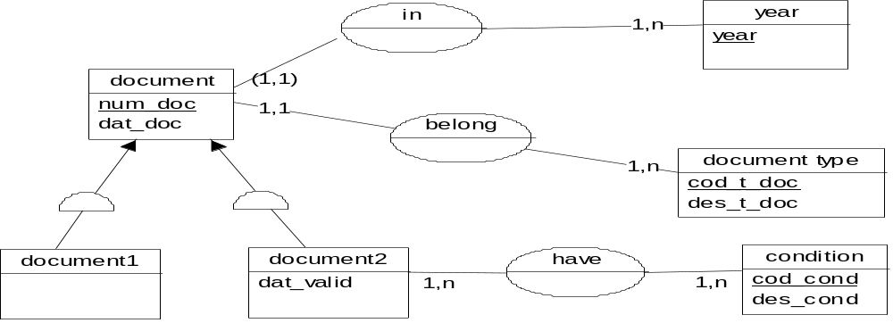

Exercise 2:
Case Study : management of a festival
A cultural association has 2 rooms with respective capacities 600 and 300 seats. This association aims to create various shows which gather the theatre, the cinema, the music and set up meetings with the public and animations various for 2 or 3 times per month.

During a festival period, several shows are offered on the same day in one or in the other room (room number, room name, and capacity) at different hours. Two different shows can be offered at the same time. However the same show can take place at a certain hour in one room and at another hour in the other according to the number of expected spectators.

Every show may be represented in many sessions. Every session is characterized by a date, an hour, the room where it is represented as well as the concerned show.

To follow such a spectacle the association offers different rates: standard rate for the public, reduced rate for the students and for children under 12 years.
Each show is identified by a show code, subject of the show, kind of the show (theatre, music...), and the people (the name with the role of each person) who represent the show.

For each reservation, the following information is recorded: date of the reservation, date and time of the session, show code, room number, name and surname of the spectator, date of birth, phone, address, category of the spectator ( student, child under 12 years old,...). The reservation can be done by phone or at the office.
The booking confirmation is guaranteed by paying and retrieving the ticket.
The association managers hope that the automation helps them to reduce the difficulties encountered before and after the shows.

Before the show:
- To ensure from the provisional reservation management taking into account the external reservations and the spectators who withdrew their tickets at the box office just before the representation.
- To establish, an hour before the show, the spectators list having confirmed and the list of spectators who have booked by phone and have not withdrawn their tickets.
الإختصاص والرمز : المعلوماتية الإدارية (23107)
المادة : طرائق التحليل

- To provide the consultation on the screen, at any time, the total number of reservations for a given show (all sessions combined) and the total number of reservations between two dates (all shows combined).

After the show:
- To know at any time the total number of the spectators:
- For all shows.
- Per rate.
- For a given show at a specific date or between two dates.

Work to do:
- Build the data dictionary. (2 pts)
- Establish the conceptual data model (MCD). (8 pts)

Exercise 3:
Study case: refund to an insured, after an incident, by an insurance company.
When an agent of the company receives an incident, he constitutes a central file from his terminal to control its validity, and then sends this statement to the headquarters of the company. The company commissions an expert then opens and saves a record of the incident.

Once the insured obtained the repair bill, he sends it to the agent, who forwards it to the company.
The expert, in turn, sends his report directly to the company.

When the person in charge at the company to manage the incident file possesses the invoice and the report, he proceeds to issue the refund check. The refund is made according to the expert report and the repair bill at the end of every month.

Work to do:
- Build the graph of flows. (2 pts)
- Deduce the conceptual treatment model (CTM). (4 pts)

